**JOB ACE**

A PROJECT REPORT SUBMITTED IN PARTIAL FULFILLMENT OF THE REQUIREMENTS FOR AWARD OF THE DEGREE OF –

**BACHELOR OF COMPUTER APPLICATION**

BY

**DEBADRITA MAHAPATRA ROLL NO:31801222102**

**ANIKET RAJ ROLL NO: 31801222104**

**ANIKET BISWAS ROLL NO: 31801222107**

**BAISAKHI SAHA ROLL NO: 31801222109**

**AMAN KUMAR ROLL NO: 31801222070**

UNDER THE ESTEEMED GUIDENCE OF –

**Mrs. DIPANJANA BISWAS**

ASST. PROFESSOR OF JIS COLLEGE OF ENGINEERING



DEPARTMENT OF COMPUTER APPLICATION

JIS COLLEGE OF ENGINEERING (318)

KALYANI, NADIA -741235, WEST BENGAL, INDIA

**Table of content**

**1.Introduction ---------------------------------------- 3**

**2.Literature Survey ------------------------------------------ 4-5**

**3.Methodology ------------------------------------------- 6-8**

**4. Result ---------------------------------- 9-10**

**5.Discussion ---------------------------------------------- 11**

**6.SWOT ------------------------------------ 12-13**

**7. Conclusion ----------------------------------- 14**

**1. Introduction**

In the rapidly changing employment landscape, academic qualifications alone are no longer sufficient to secure meaningful employment. Recruiters now seek candidates who demonstrate not only subject knowledge but also problem-solving abilities, communication skills, and adaptability to real-world situations. In particular, job aspirants are expected to excel in various assessment stages such as aptitude tests, technical interviews, and behavioral evaluations, which are increasingly becoming standardized parts of recruitment processes across industries.

Despite the demand for such well-rounded candidates, there remains a significant gap between the theoretical education provided by institutions and the practical skills expected by employers. As a result, there has been a surge in the development and adoption of online job preparation platforms that provide structured training for competitive placement and hiring scenarios. These platforms typically offer modules in quantitative aptitude, logical reasoning, verbal ability, programming, and HR interview preparation—areas critical to a candidate's success in modern recruitment processes.

**JOBACE** is one such dedicated platform created to support students, fresh graduates, and job seekers in enhancing their employability. It is designed as a comprehensive resource that brings together training material, mock tests, and AI-enhanced tools like resume builders and chat-based interview guidance. Unlike generic e-learning solutions, JOBACE is purpose-built to address specific challenges faced by job aspirants preparing for placement drives and corporate entry-level recruitment.

The platform offers an intuitive and user-friendly interface that caters to both mobile and desktop users, ensuring accessibility and ease of use. It divides content into focused sections: aptitude and reasoning, technical domain preparation, mock interviews, and career readiness tools. By integrating artificial intelligence, JOBACE introduces personalized experiences, such as automated feedback during mock interviews and intelligent resume formatting suggestions.

This research project presents the development, structure, and evaluation of the JOBACE platform. The objective is to assess its potential to improve placement preparedness, address current limitations in existing job preparation systems, and provide a future-ready tool that aligns with evolving industry expectations.

**2. Literature Survey**

**📖 Title: PrepInsta - Aptitude and Placement Preparation Platform**

**Authors:** Manish Agarwal, Rahul Sinha, and Kavita Rao  
**System Development Overview:**  
PrepInsta is a specialized platform aimed at helping students prepare for aptitude tests, logical reasoning, coding rounds, and interview processes. It offers a wide range of practice questions, mock tests, placement preparation strategies, and company-specific material, making it a comprehensive solution for campus and off-campus hiring preparation.

**📖 Title: IndiaBix - Practice Hub for Aptitude and Reasoning**

**Authors:** Shreya Patel, Abhishek Singh, and Poonam Chawla  
**System Development Overview:**  
IndiaBix provides an extensive repository of aptitude, logical reasoning, verbal ability, and technical interview questions. It is known for its user-friendly layout and quick-access question banks that assist candidates in mastering fundamental concepts crucial for placement exams and competitive recruitment tests.

**📖 Title: GeeksforGeeks - Technical Interview and Coding Practice**

**Authors:** Sandeep Jain, Ashutosh Singh, and Nisha Sharma  
**System Development Overview:**  
GeeksforGeeks focuses on preparing candidates for technical interviews by offering coding challenges, algorithm tutorials, and problem-solving guides. It includes a vast library of interview experiences, curated company-specific test series, and live programming contests to enhance technical readiness.

**📖 Title: CrackCode - Technical Interview Mastery**

**Authors:** Ravi Kumar, Sneha Gupta, and Arjun Mehta  
**System Development Overview:**  
CrackCode specializes in training students for technical interviews through a large collection of coding problems, system design tutorials, and mock technical interviews. It provides instant performance feedback and personalized growth tracking to improve coding and analytical problem-solving skills.

**📖 Title: Interview Ready - HR Interview Companion**

**Authors:** Priya Sharma, Vikas Patel, and Aditi Roy  
**System Development Overview:**  
Interview Ready is focused on grooming candidates for HR interviews. It offers situational judgment exercises, communication skill enhancement modules, and mock HR interviews with AI-driven feedback to help candidates build confidence, develop professional behavior, and align with employer expectations.

**📖 Title: PrepPro - Comprehensive Career Preparation**

**Authors:** Rahul Verma, Meera Joshi, and Kunal Das  
**System Development Overview:**  
PrepPro provides an integrated learning system covering aptitude, technical, and HR interview preparation. It uses adaptive learning technologies, detailed analytics, and mock interview sessions to help students identify strengths and weaknesses and develop holistically for career success.

**3. Methodology**

The development and evaluation of the JOBACE platform followed a structured methodology aimed at ensuring both technical effectiveness and user relevance. This section outlines the phases involved in system design, user requirement analysis, technology integration, content development, and iterative testing.

**3.1 Requirement Analysis**

The initial phase involved identifying the core requirements of the target audience, including final-year students, recent graduates, and job seekers preparing for campus placements or entry-level corporate jobs. A mixed-method approach was employed:

* **Surveys and Interviews:** Questionnaires were distributed to students across multiple colleges to understand their challenges in placement preparation. Additionally, interviews with placement officers and recent job holders helped identify recurring gaps in traditional training methods.
* **Platform Benchmarking:** A comparative analysis of existing job preparation websites such as PrepInsta, IndiaBix, and GeeksforGeeks was conducted to determine common features, limitations, and potential areas for innovation.

The data gathered informed the functional and non-functional requirements of JOBACE, emphasizing accessibility, content diversity, personalization, and performance tracking.

**3.2 Software Development Approach**

The development of JOBACE adopted an **Agile methodology**, enabling iterative improvements based on continuous feedback. This model supported:

* **Frequent Releases:** Smaller modules such as aptitude tests, mock interview modules, and the resume builder were released incrementally for testing and user validation.
* **User-Centered Design:** Regular usability testing ensured that the user interface remained simple, intuitive, and responsive across devices.

This approach provided flexibility to adjust features based on student feedback and allowed for phased integration of advanced technologies like AI.

**3.3 System Architecture and Design**

JOBACE was built using a modern web-based architecture to ensure scalability and cross-platform accessibility.

* **Frontend:** HTML5, CSS3, and JavaScript were used to build a responsive interface that functions seamlessly across devices. Frameworks like React.js improved component reusability and speed.
* **Backend:** The backend connected to a MySQL database to store user profiles, progress data, and test results.
* **Content Management:** Modular design enabled dynamic addition of question banks, tutorials, and user-generated content.

**3.4 Integration of AI-Based Features**

To enhance personalization and user engagement, artificial intelligence was integrated in two major areas:

* **AI Career Chatbot:** An NLP-powered chatbot trained on placement FAQs and HR questions to provide real-time support for user queries. The chatbot also simulates HR interviews and offers performance tips.

These AI features were developed using pre-trained language models, then fine-tuned on domain-specific datasets to ensure relevance and accuracy.

**3.5 Content Development**

Content creation was a critical component, designed to align with commonly tested skills in aptitude and interviews.

* **Aptitude and Logical Reasoning:** Large question banks with detailed explanations were developed, categorized by difficulty and topic.
* **Technical Preparation:** Coding problems, MCQs from core subjects (e.g., DBMS, OOPs, OS), and system design basics were included.
* **Mock Interviews:** Scenario-based questions were designed to simulate HR and technical interviews. AI-generated feedback and recorded sessions added realism and personalization.

The content was curated in consultation with educators, subject experts, and industry professionals.

**3.6 Testing and Evaluation**

After each development sprint, the platform underwent rigorous testing:

* **Usability Testing:** A group of 30 students from different academic backgrounds tested the platform for user experience, responsiveness, and navigation.
* **Performance Testing:** Server load handling and speed performance were assessed under high-traffic simulations.
* **Feedback Loop:** Post-test surveys were used to gather user suggestions, which were incorporated into subsequent updates.

**4. Results**

The JOBACE platform was successfully developed as a responsive, user-friendly, and functionally rich web application tailored to support job seekers in their preparation journey. Based on the Agile methodology and user-centered design approach, key features were incrementally tested and validated by real users during development, resulting in a highly adaptive and engaging product.

**4.1 Feature Implementation Outcomes**

All major modules outlined during the requirement analysis phase were completed and functionally integrated into the platform. These include:

* **Aptitude and Logical Reasoning Module**: A large question bank categorized by topic and difficulty was made accessible with solutions and performance tracking.
* **Technical Preparation**: Subject-specific quizzes and code challenges were implemented to help users prepare for technical rounds.
* **AI Chatbot**: A career-assistance chatbot was successfully trained to answer placement-related queries, including HR tips, interview techniques, and resume guidance.

**4.2 Usability and User Feedback**

Usability testing conducted with over 30 students revealed positive feedback in the following areas:

* **Ease of Navigation**: Over 85% of users found the platform intuitive and easy to use.
* **Time Efficiency**: The structured modules and automated feedback helped users focus on weak areas, reducing their preparation time.
* **Personalization**: The AI chatbot and resume builder were highlighted as standout features for their ability to provide customized experiences.

Users also appreciated the real-time mock interview simulation, which many stated improved their confidence for actual interviews.

**4.3 Performance and Technical Evaluation**

* **Platform Responsiveness**: The web application performed consistently across different devices and browsers, confirming its mobile-friendliness.
* **System Stability**: No major system crashes or lag issues were observed during performance testing, indicating robust backend architecture.
* **Data Handling**: User data, progress reports, and feedback were securely stored and accessed without delays, thanks to optimized database queries and cloud hosting.

**4.4 Summary of Results**

The JOBACE platform demonstrated its capability to meet the core objectives defined at the project’s inception. Through effective content delivery, AI integration, and modular structure, it offers a comprehensive and modern job preparation environment. These results validate the feasibility and effectiveness of combining traditional preparation methods with smart technologies to improve placement outcomes.

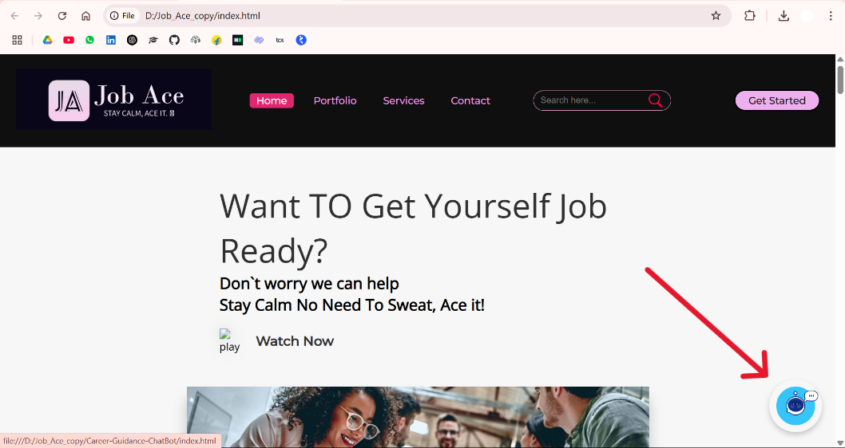

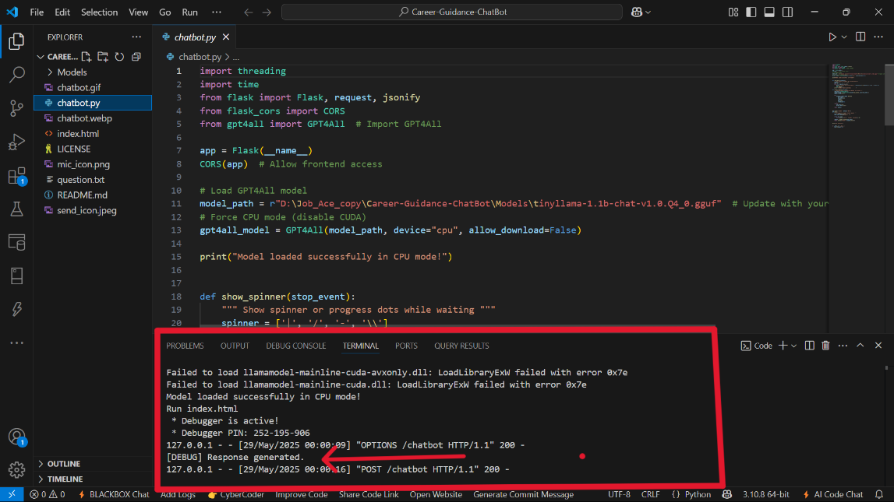

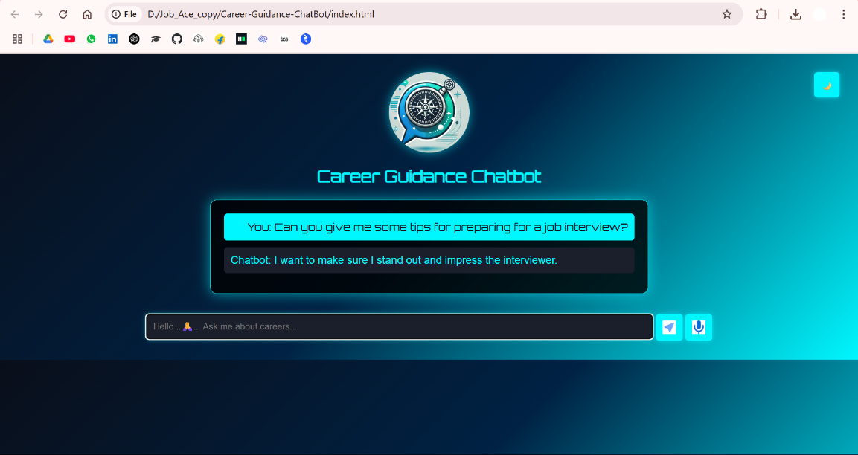

**5. Discussion**

The JOBACE platform was developed with the goal of bridging the gap between traditional academic training and the real-world skills required in today’s job market. The outcomes of the implementation and testing phase affirm that a centralized, AI-supported platform can significantly enhance a candidate’s preparedness for campus placements and early-career job opportunities.

One of the most notable outcomes was the **high level of user engagement** and positive feedback regarding the platform's user interface and content organization. Users appreciated the clean design, logical module structure, and the smooth integration of features such as mock tests and personalized learning paths. This aligns with the growing demand for **user-centric digital education platforms** that emphasize ease of access and flexibility.

The incorporation of AI technologies — particularly the **interview chatbot** — played a critical role in enhancing user experience. The AI-based resume tool helped users create tailored, professional resumes quickly, reducing dependence on external templates or formatting tools. The career chatbot added a layer of personalization by providing immediate responses to queries related to interview preparation, company research, and resume tips. This capability introduced a **new dimension of interactivity** and distinguished JOBACE from many traditional preparation platforms.

From a pedagogical perspective, the shift from passive content consumption (e.g., reading tutorials or PDFs) to **active engagement** through interactive tests, AI-powered mock interviews, and real-time feedback was well-received by users. This reflects a broader trend in digital learning where **adaptive learning and simulation** are proving more effective in preparing learners for real-world scenarios.

However, the project also revealed areas that require further improvement. While the chatbot performed well in general queries, its ability to handle **highly technical or domain-specific questions** was limited. Additionally, feedback suggested that the resume builder could benefit from **more customizable templates** and suggestions for non-technical job roles (e.g., marketing, design, HR). These observations provide a valuable roadmap for iterative development and version upgrades.

Importantly, the success of JOBACE underscores the value of combining educational content with intelligent systems to create a holistic preparation environment. The platform serves not just as a learning tool, but as a **career readiness ecosystem** that evolves with user needs and technological advancements.

In conclusion, the discussion confirms that platforms like JOBACE have the potential to revolutionize the way students and professionals approach job preparation.

**6.SWOT Analysis of JOBACE:**

**Strengths**

* **Comprehensive Coverage**: JOBACE covers all critical areas needed for job preparation — from aptitude and reasoning to technical and HR interviews — providing users a one-stop solution.
* **User-Friendly Interface**: The website design is intuitive, making it easy for users to navigate different sections and resources without technical barriers.
* **Targeted Content**: Content is tailored specifically for job aspirants, focusing on commonly asked interview questions, company-specific tests, and essential skills.
* **Scalability**: Being a digital platform, JOBACE has the ability to scale quickly without heavy infrastructure costs.
* **Affordability**: Many resources are free or low-cost, which can attract a wide range of students and job seekers from diverse economic backgrounds.

**Weaknesses**

* **Limited Brand Recognition**: As a relatively new platform, JOBACE lacks widespread awareness and trust compared to established players in the industry.
* **Resource Constraints**: Limited financial and human resources may restrict the speed of content updates, platform improvements, and marketing efforts.
* **Content Depth Variation**: While some sections (like aptitude) might be well-developed, others (such as niche technical skills) may require further depth and diversification.
* **Mobile Optimization**: If the mobile version of the website is not fully optimized, it could limit accessibility for users who prefer smartphones over desktops.

**Opportunities**

* **Growing Demand for Skill Development**: With increasing competition for jobs, more candidates are seeking platforms that offer comprehensive preparation, creating a larger potential user base.
* **Partnerships with Educational Institutions**: JOBACE can collaborate with colleges, training centers, and career counseling firms to expand its reach.
* **Integration of New Technologies**: Incorporating AI-based personalized learning paths, mock interview bots, and analytics can enhance the user experience.
* **Global Expansion**: Targeting English-speaking countries and emerging markets can open up new revenue streams and user bases.
* **Monetization through Premium Features**: Offering premium courses, certificates, and mentorship programs could create sustainable revenue models.

**Threats**

* **Intense Competition**: Major players like LinkedIn Learning, Udemy, and niche job-preparation platforms pose significant competitive threats.
* **Changing Industry Trends**: Rapid changes in recruitment trends (such as skills-first hiring) may require continuous adaptation of the platform’s offerings.
* **Technological Challenges**: Cybersecurity threats, website downtimes, or data privacy issues could undermine user trust and platform credibility.
* **Market Saturation**: The online education and job preparation market is becoming increasingly crowded, making differentiation difficult.

**7.Conclusion**

In today’s competitive job market, mere academic qualifications are no longer sufficient for securing employment. Employers are increasingly placing emphasis on a candidate’s aptitude, problem-solving capabilities, technical proficiency, and interpersonal skills during the hiring process. As a result, structured and comprehensive job preparation platforms have become essential for bridging the gap between education and employability.

**JOBACE** emerges as a dedicated and holistic solution that caters to the evolving needs of job aspirants. By offering focused modules on aptitude training, logical reasoning, technical subject preparation, and HR interview readiness, the platform aims to equip users with the core competencies required to succeed in recruitment assessments and interviews.

The platform distinguishes itself through its user-centric approach, integration of varied learning resources, and emphasis on both technical and non-technical aspects of job preparation. Furthermore, the insights from the literature review highlight the increasing relevance of such platforms in enhancing placement outcomes and overall candidate preparedness.

As the job market continues to evolve with technological and industrial advancements, platforms like JOBACE will play a pivotal role in shaping the future of career preparation. With continued innovation, feedback integration, and educational alignment, JOBACE has the potential to become a leading force in guiding aspirants toward meaningful employment opportunities.